HKLPDPS2B001

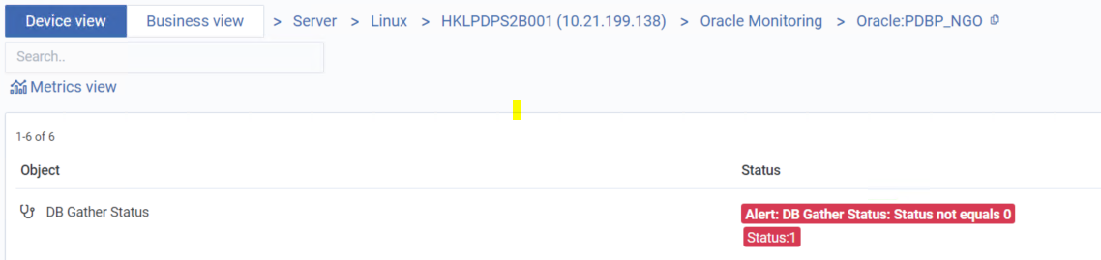

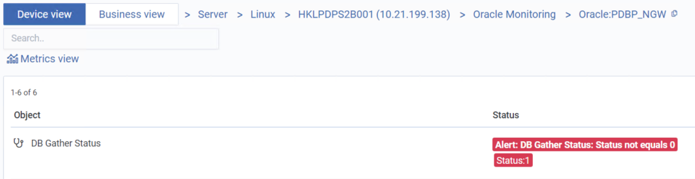

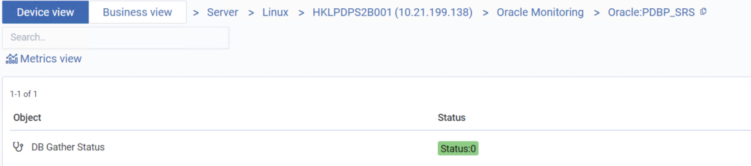

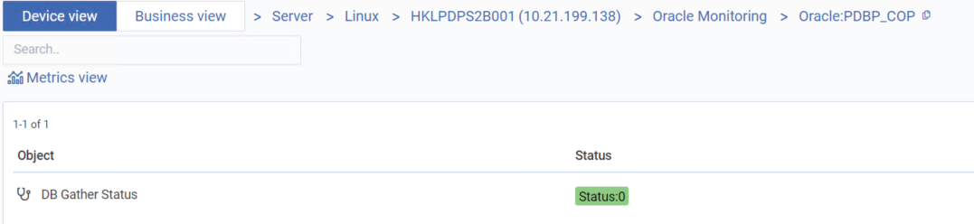

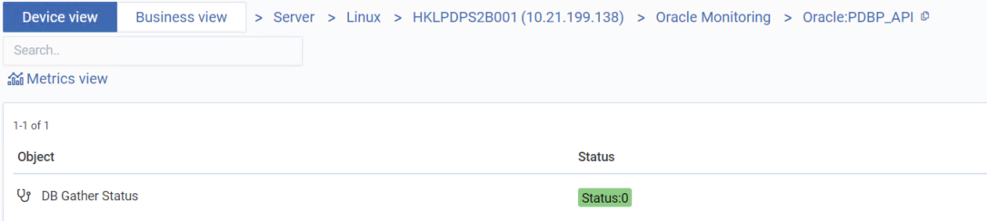

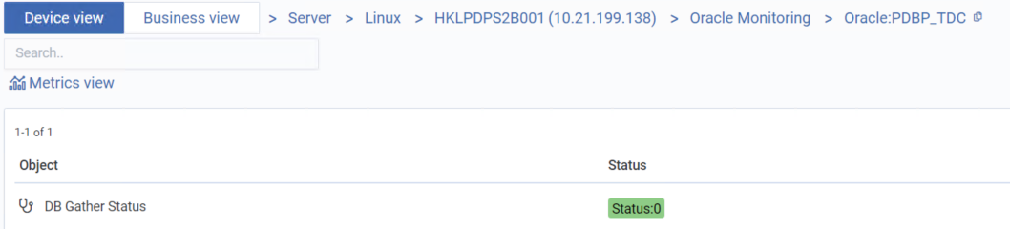

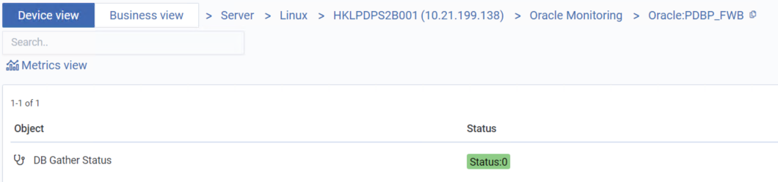

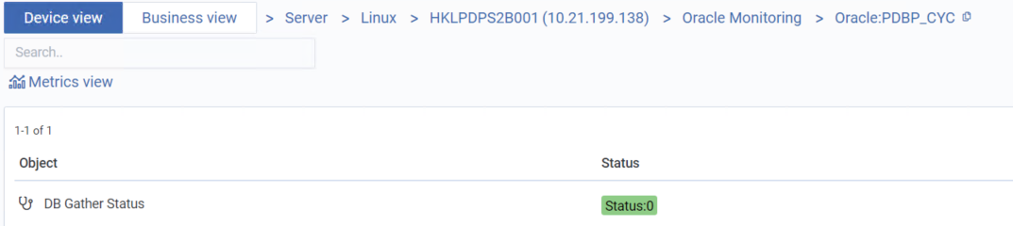

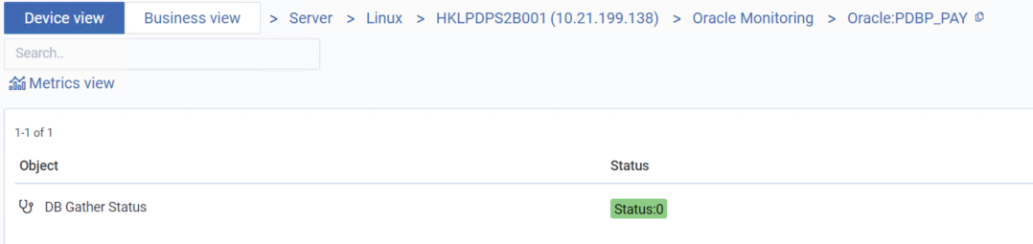

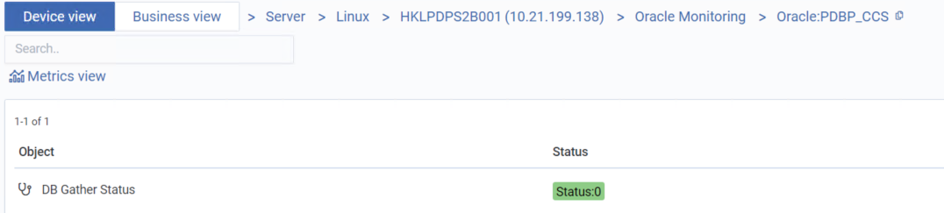

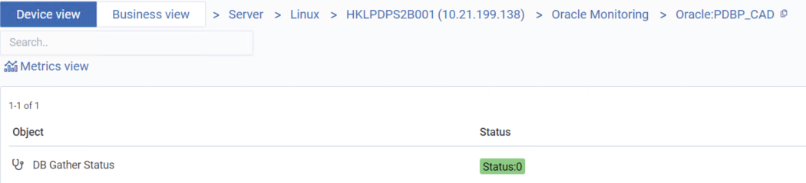

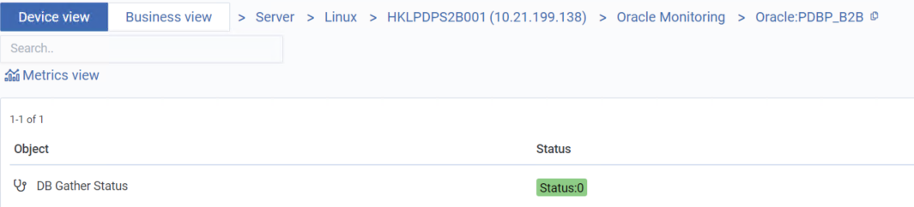

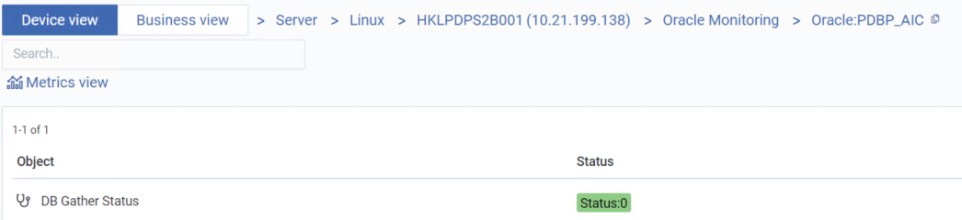

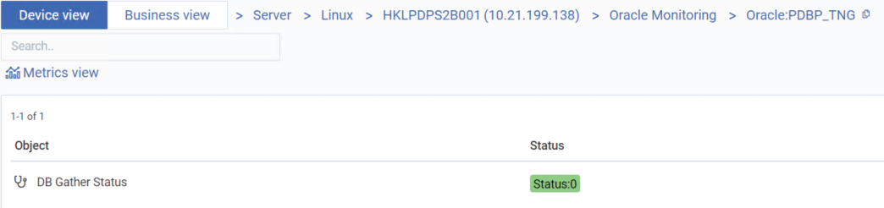

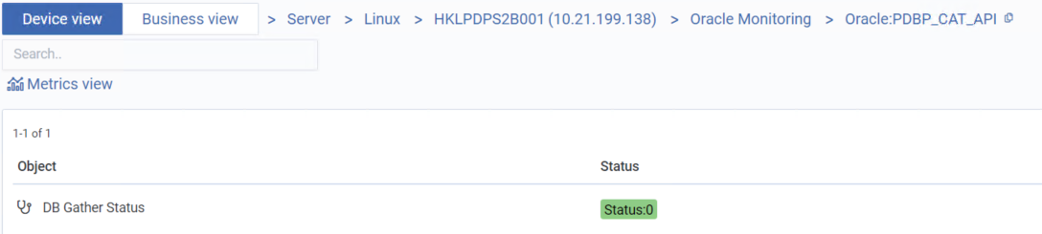

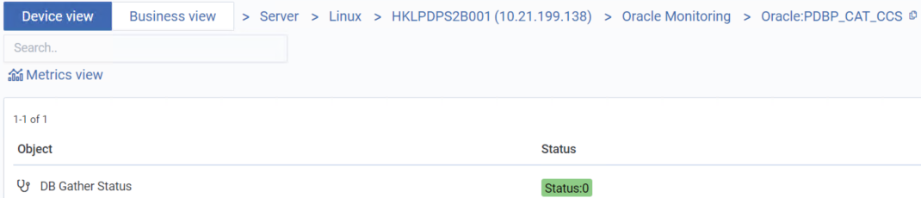

HKLPDPS2B002

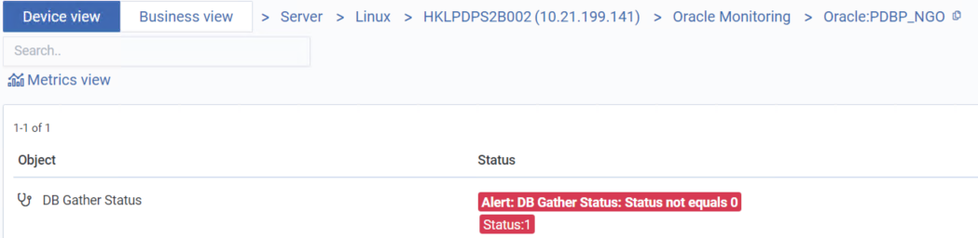

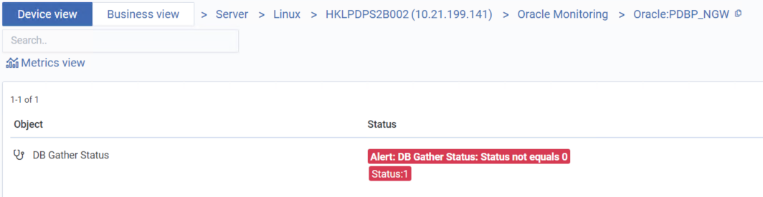

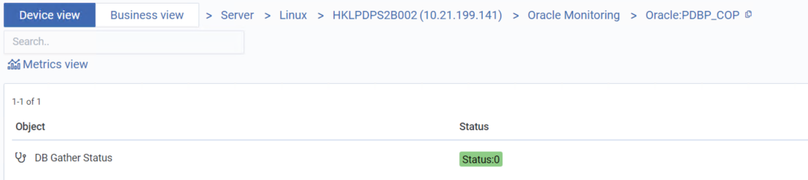

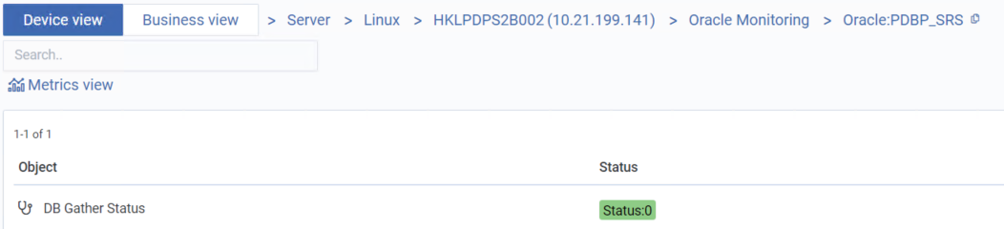



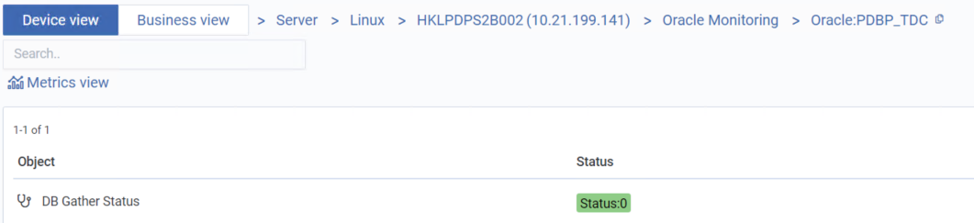

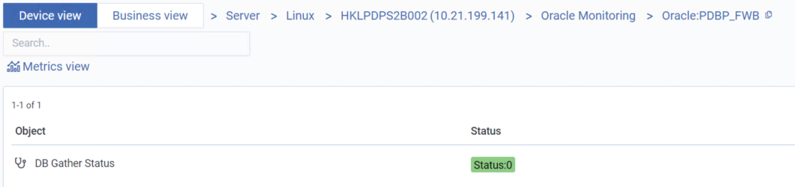

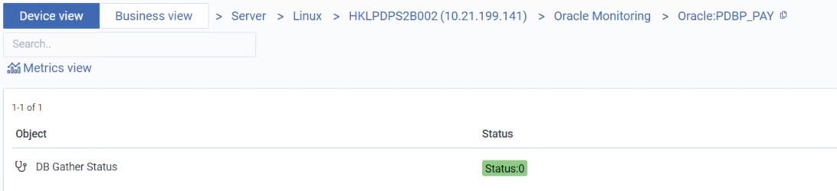

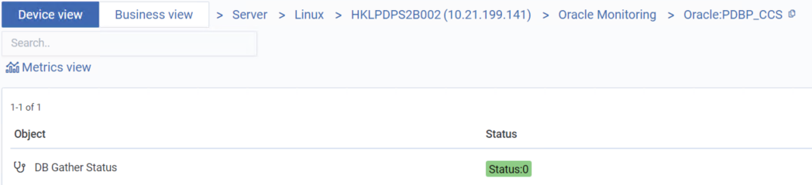

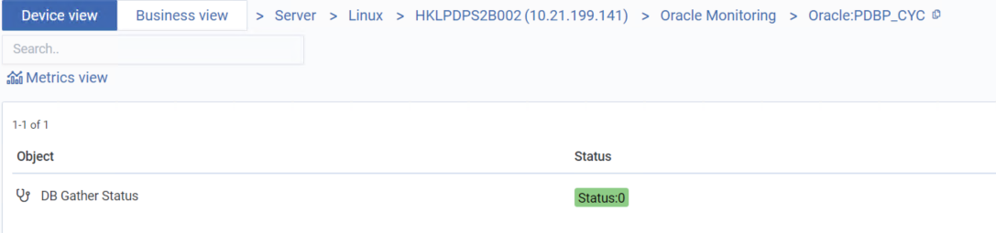

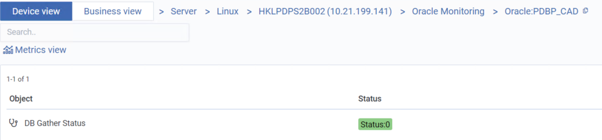

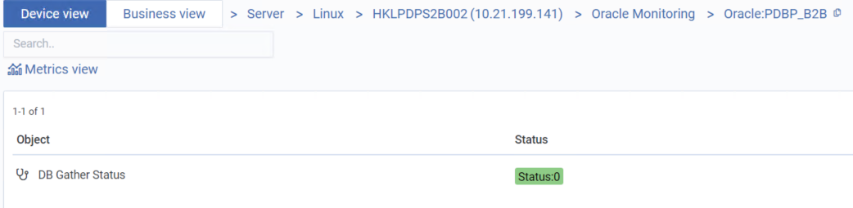

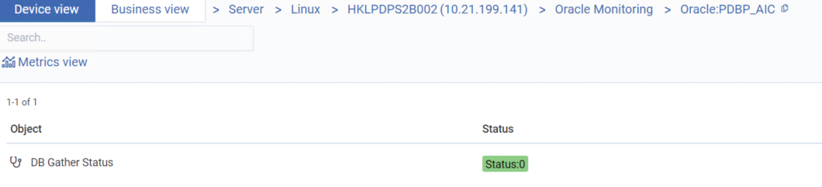

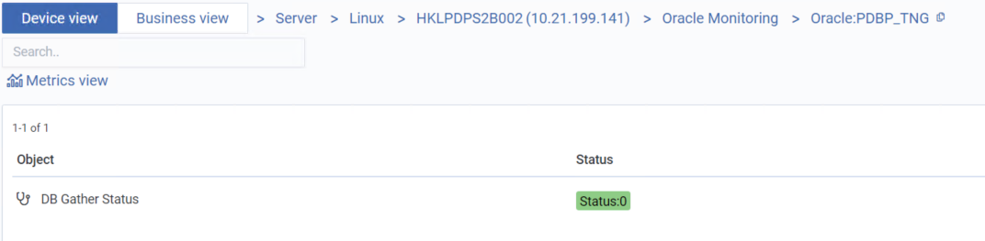

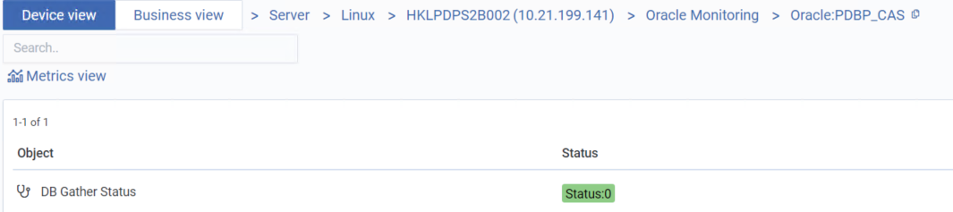

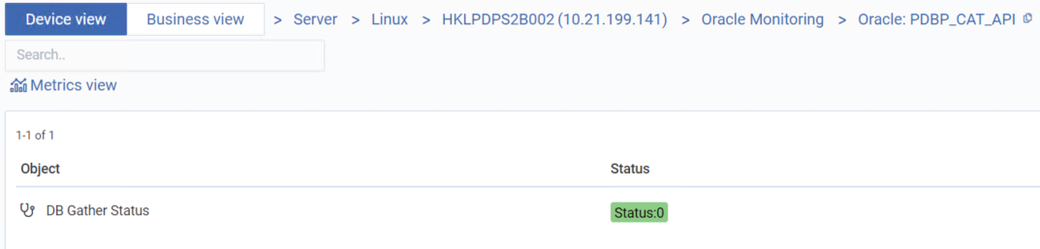

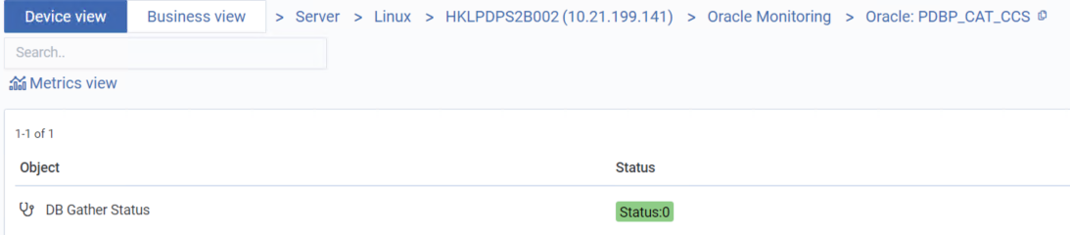

HKLPDPS2B003

